**Prelab-Week-5**

**Prelab Questions:**

1. How Greedy approach different from Divide and Conquer?

2. Write the control abstraction for Greedy approach.     
3. Differentiate between feasible solution and optimal solution?  
4. What is the time complexity of Prim’s algorithm?

5. Write the significance of Union and Find operation in Kruskal’s algorithm

6. Find minimum spanning tree by using Prim’s and Krukals’s algorithms for the graph given below

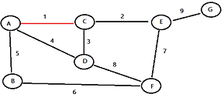

**Pre-lab programs:**

1. Implement Kruskal’s minimum cost spanning tree algorithm
2. Implement Prim’s minimum cost spanning tree algorithm